# Practical Exercise: Machine Learning Operations

## 1) Problem Statement

## Perform the following operations using R/Python on suitable data sets:

## a) read data from different formats (like csv, xls)

## b) indexing and selecting data, sort data,

## c) describe attributes of data, checking data types of each column,

## d) counting unique values of data, format of each column, converting variable data type (e.g. from long to short, vice versa),

## e) identifying missing values and fill in the missing values

## 2) Libraries Used

Python:  
Pandas: For data manipulation and preprocessing.  
NumPy: For numerical operations and array manipulation.  
Scikit-learn: For machine learning algorithms and model evaluation.  
Matplotlib/Seaborn: For data visualization.  
Possibly additional libraries like TensorFlow or PyTorch for advanced machine learning models (optional depending on the complexity of the problem).

## 3) Theory

The theory section covers data preprocessing, model selection and training, model evaluation, and model deployment. It discusses techniques for handling missing values, encoding categorical variables, scaling numerical features, choosing appropriate machine learning algorithms, evaluating models using metrics like accuracy, and deploying models for real-world applications.

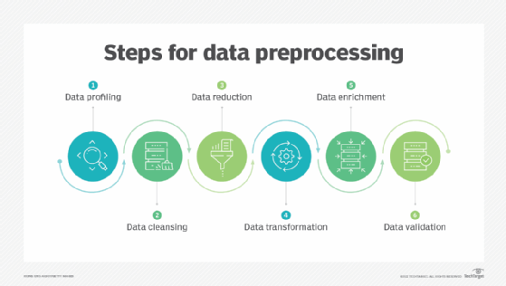

## 4) Methods

Methods involve data preprocessing, model selection and training, model evaluation, and model deployment. These include handling missing values, encoding variables, scaling features, choosing and training appropriate models, evaluating them with suitable metrics, and deploying the selected model in production.

## 5) Advantages and Disadvantages

Advantages of using ML include the ability to predict customer responses effectively, optimizing marketing strategies, and automating decision-making processes. Disadvantages include the requirement for large amounts of data, the risk of overfitting or underfitting, and potential challenges in interpreting model outputs.

## 6) Working

The working section details the systematic application of data preprocessing, model selection, training, evaluation, and deployment to solve the classification problem of predicting customer responses for special offers. It includes continuous monitoring and updates to ensure the model adapts to changing conditions.

## 7) Conclusion

Conclusively, applying machine learning algorithms to predict customer responses for special offers provides valuable insights. By preprocessing data, selecting suitable algorithms, and evaluating model performance, businesses can enhance customer engagement and sales. Continuous performance monitoring and adaptation are crucial to maintain competitiveness.